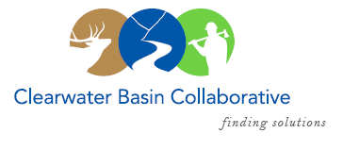

Clearwater Basin Collaborative
Steering Committee
April 12, 2017 - 8:30am PAC/9:30am MTN
Conference Call: (208) 252-6102, no pin required

AGENDA

Discussion Items
- Notes from March 8, 2017 (Co-Chairs)
- April Working Group Agenda
  - Mark Haggerty, Headwaters Economics - Secure Rural Schools (Joyce)
  - Bob Lippencott – USFS Fire Presentation (Elayne)
  - Road Closure and Winter Effects – USFS (Alex)
  - Restoration Action Strategy – request to present (Tera)
  - Forest Plan Revision – Status Report (Elayne)
  - Forest Service – Request Forest and Region participation (All)
- National Stewardship Trail Act (Randy)
  - Next Steps?
- CFLR Project – Status Report (Tera/Mike W.)
  - Annual Planning Session - Missoula
  - FY 16 Annual Report / FY 17 Priorities
  - Monitoring Advisory Committee Meeting – March 30 Report Out
  - Washington Office Visit - July
- Membership (Co-Chairs)
  - Back Country Hunters & Anglers – Charles “Hoey” Stewart (Official Request)
  - Dennis Duman, Idaho County Commissioner – Meet
- August Recess Conversation (Co-Chairs, All)
  - Introductions
  - Planning
- Correspondence & Status Update (Co-Chairs)
  - Windy Shingle Project, Comment Letter
  - Ecosystems Research Group, Recommendation Letter
- Committee Member Agenda Item Requests (All)
- Calendar of Events (All)

