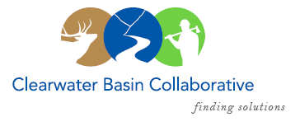

Clearwater Basin Collaborative
Steering Committee
April 13, 2016 - 8:30am PAC/9:30am MTN
Conference Call: (208) 252-6102, no pin required

AGENDA

Discussion Items
- Notes from March 9, 2016
- Membership / Succession Planning Strategy (Co-Chairs)
  - Trout Unlimited
  - Back Country Hunters & Anglers
  - Member At Large, Aldrich
  - Nez Perce Tribe
- Work Plan Prioritization Follow Up (Co-Chairs)
  - Results from Co-Chair Meeting & Working Group
- April Working Group Meeting (All)
  - Nominating & Operating Protocol Committee – Elections & Protocols
- May 25th & 26th Retreat Planning (Olleke, Co-Chairs)
  - Plan May Retreat
- Notice to Steering Committee (All)
  - Nez Perce Travel Management Objection Notice
  - Suction Dredge Mining Objection
- CFLR Project (All)
  - Johnson Bar
  - Clear Creek
- North Central Idaho RAC Funding Secured (Alex)
- Committee Member Agenda Item Requests (All)
- Calendar of Events (All)

