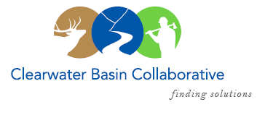

Clearwater Basin Collaborative
Steering Committee
August 10, 2016 - 8:30am PAC/9:30am MTN
Conference Call: (208) 252-6102, no pin required

AGENDA

Discussion Items
- Notes from July 14, 2016
- Nominating & Operating Protocol Committee (Co-Chairs)
  - Update - Membership / Succession Planning Strategy (Co-Chairs)
    - Vacancies on Working Group – Scott Stouder, Holly Endersby
    - Invite IDL and IDPR to become official voting Working Group members
    - Operating Protocol tweaks
    - Targeted Working Group Member Recruitment
- GEM Trail Grand Opening – October 8th (Alex)
  - Communications
- Clearwater Travel Plan – Status Report (Dale)
- CFLR Project
  - CBYCC End of Year Update (Tera)
  - Clear Creek Litigation (Co-Chairs)
    - Forest Service / Tribal Meeting Update
    - Amended Complaint
- August 24th Working Group Meeting (Co-Chairs, All)
  - Call for Agenda items
- Committee Member Agenda Item Requests (All)
- Other
- Calendar of Events (All)

