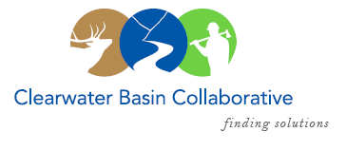

Clearwater Basin Collaborative
Steering Committee
August 9, 2017 - 8:30am PAC/9:30am MTN
Conference Call: (208) 252-6102, no pin required

AGENDA

Discussion Items
- Notes from July 12, 2017 (Co-Chairs)
- Selway Middle Fork CFLR (Mike/Tera)
  - CBYCC Season Finale
  - Washington Office follow up
  - Missoula Strategy Session
- Collaboration Cadre (Brad Smith/Mitch Silvers)
- Washington Office Recess and Visitation
  - Secretary Purdue Invitation (Kelli)
  - August Recess (Joyce)
  - East Saddle Field Trip (Kelli)
- Recreation Subcommittee: Jahn Studios Contract (Randy)
- August Working Group Meeting and Agenda (Co-Chairs, All)
  - Request for Agenda Items
- Wildlife Habitat Restoration Initiative (Kelli/Alex)
  - MOA regarding Graduate Student Fellowship and Intellectual Property with Washington State University
- Correspondence:
  - Probert, Wild and Scenic Rivers Suitability
- Coordinator Vacation – Aug 11- 20
- Committee Member Agenda Item Requests (All)

