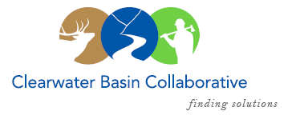

Clearwater Basin Collaborative
Steering Committee
December 2, 2016 - 8:00am PAC/9:00am MTN
Conference Call: (208) 252-6102, no pin required

AGENDA

Discussion Items
- Notes from November 9, 2016 (Co-Chairs)
- Wildlife Habitat Restoration Initiative (Alex, Kelli)
  - Rocky Mountain Elk Foundation - Meeting report out
  - Upcoming Capture Activities – FYI
  - Forthcoming Modeling efforts by Pacific NW Research Station
- December Working Group Agenda
  - Wildlife Habitat Restoration Initiative (Alex)
  - Forest Plan Revision – Presentation request on wildlife (Elayne)
  - Regional and Forest Wildlife Staff Visit (Michele)
- Forest Activities
  - CFLR Project (Mike W.)
    - Revised/Amended CFLR Proposal
    - FY 16 Annual Report
  - Orogrande Project - litigation and next steps (Dale)
- Woodland Magazine Article (Elayne)
- Idaho GEM Trail – Update (Randy/Alex)
- January All Co-Chair Meeting (Co-Chairs)
  - Dates
  - Location – Coeur d’Alene
- Committee Member Agenda Item Requests (All)
- Calendar of Events (All)

