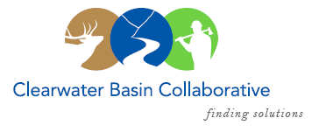

Clearwater Basin Collaborative
Steering Committee
December 9, 2015 - 8:30am PAC/9:30am MTN
Conference Call: (208) 252-6102, no pin required

AGENDA

Discussion Items
- Notes from November
- Wildlife Habitat Restoration Initiative (Alex/Kelli)
  - Early Winter Capture Activities underway
  - January Working Group Update/Report
- CBC Legislative Concepts Update (Jim)
  - Implementation Committee/Committee of New Ideas
- Selway Middle Fork CFLR – (Mike Ward/Dale)
  - Clear Creek Rollout and January Presentation to Working Group
  - Phase III Landscape Assessment – next steps
  - Missoula Session Report Out
  - CBYCC Video Roll Out
- Operating Protocol Subcommittee Meeting (Randy)
- Communications to USFS Regional Office (Dale)
- Grant Announcements (Kelli)
  - Every Kid in the Park Transportation Grant
- Calendar of Events (Co-Chairs)
  - January 27th Working Group Meeting
    - Clear Creek Roll Out
    - Wildlife Habitat Report
  - February 23rd All Co-Chair Meeting
  - February 24th & 25th Idaho Forest Restoration Partnership – Boise
- Other

