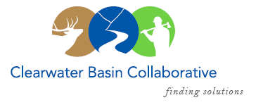

Clearwater Basin Collaborative
Steering Committee
February 10, 2016 - 8:30am PAC/9:30am MTN
Conference Call: (208) 252-6102, no pin required

AGENDA

Discussion Items
- Notes from January 13, 2016
- All Co-Chair Meeting - February 23rd (Co-Chairs, Kelli)
  - TWS/TNC Conference Room
  - Request for Agenda Items
- IFRP Conference – February 24th & 25th (All)
  - Agency and State Meetings
    - Idaho Dept. of Lands - confirmed
    - Idaho Dept. of Fish & Game - confirmed
    - Idaho Dept. of Parks & Rec - pending
  - Legislative Reception – Red Feather Cellar - pending
  - Presenters: Elayne Murphy, Cheryl Probert - confirmed
  - Presentation Stand – CBYCC, Abraham Lincoln Award, Wildlife
- Memorandum of Understanding – What’s Next ( Elayne)
- Website Roll Out (Kelli)
  - Public Announcement Strategy
  - Continuing Subcommittee Updates
- North Central Idaho RAC Request (Elayne)
- Committee Member Agenda Item Requests (All)
- Calendar of Events (All)
- Other

