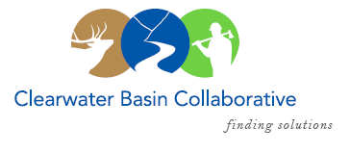

Clearwater Basin Collaborative
Steering Committee
January 11, 2017 - 8:30am PAC/9:30am MTN
Conference Call: (208) 252-6102, no pin required

AGENDA

Discussion Items
- Notes from December 2, 2016 (Co-Chairs)
- January Working Group Agenda (All)
  - Report on Accomplishments
  - Annual Plan of Work
- National Stewardship Trail Act (Dale)
  - Synopsis
  - Request from Outfitters & Guides
- February & March Working Group Meetings (Co-Chairs)
  - Wildlife focus
  - Forest Plan Revision – Presentation request on wildlife
  - Threatened and Endangered Species
  - Regional Office Request for attendance
- Forest Plan Revision Subcommittee – update (Elayne/Kelli)
- All Co-Chair Meeting – (Co-Chairs)
  - New proposed date Thursday, January 26
  - Agenda distribution
  - Date and Location
- Wildlife Habitat Restoration Initiative (Alex, Kelli)
  - Capture Activities – Results
- Membership (Co-Chairs)
  - Trout Unlimited – Michael Wells, Chapter President
  - Working Group Vacancies
    - Back Country Hunters & Anglers
    - Citizen Liaisons
- CFLR Project (Tera/Mike W.)
  - CFLR Coordinator’s return
  - Revised/Amended CFLR Proposal
  - FY 16 Annual Report
- Community Support for Projects (Alex)
  - Request from Idaho Youth Challenge Academy – C. St. Germaine
  - Guidance on future Support Requests
- Committee Member Agenda Item Requests (All)
- Calendar of Events (All)

