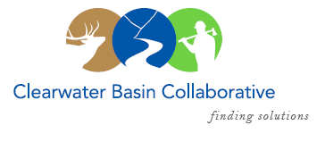

Clearwater Basin Collaborative
Steering Committee
January 13, 2016 - 8:30am PAC/9:30am MTN
Conference Call: (208) 252-6102, no pin required

AGENDA

Discussion Items
- Notes from December
- CBC Revamped Website Rollout (Kelli)
  - Rollout and Outreach Communications
  - Further Development of Subcommittee Pages
- Wildlife Habitat Restoration Initiative (Alex/Kelli)
  - Early Winter Capture Activities Complete (attach report)
  - January Working Group Update/Report Out
- Committee Member Agenda Item Requests
  - Equestrian Trail support letter (Holly)
  - Contractor Training (Joyce)
  - Salvage Logging in Roadless CE areas (Brad)
  - Suction dredge mining (Holly)
  - Senator Crapo's Office Communications (Holly)
- Memorandum of Understanding (Alex)
- All Co-Chair Meeting in February (Alex)
  - Location
  - Agenda Items
  - Legislative Reception
  - Agency and State Meetings?
- IFRP Conference – February 24th & 25th (All)
  - Presentation Stand – CBYCC
- Calendar of Events (Co-Chairs)
  - January 27th Working Group Meeting
    - Clear Creek Roll Out
    - Wildlife Habitat Report
  - February 23rd All Co-Chair Meeting
  - February 23rd Legislative Reception
  - February 24th & 25th Idaho Forest Restoration Partnership – Boise
  - February Working Group Meeting?
- Other

