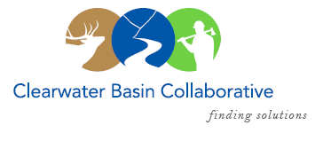

Clearwater Basin Collaborative
Steering Committee
July 12, 2017 - 8:30am PAC/9:30am MTN
Conference Call: (208) 252-6102, no pin required

AGENDA

Discussion Items
- Notes from June 14, 2017 (Co-Chairs)
- Selway Middle Fork CFLR (Mike/Tera)
  - July 27th Washington Office – Missoula
  - July 28th Strategy Session – Missoula
- Wildlife Habitat Restoration Initiative (Alex/Kelli)
  - MOU with Washington State University
- Collaboration Cadre (Brad Smith/Mitch Silvers)
- Pew Charitable Trust Visit by Marni Salmon (Dale)
- Secretary Purdue Invitation (Co-Chairs)
- July Working Group Meeting and Agenda (Co-Chairs, All)
  - FS Special Presentation: The Next 100 Years
  - Committee Reports
    - Forest Plan Revision
    - Recreation Subcommittee
    - Landscape Forest Health
- August Recess Washington Office Planning (Co-Chairs, All)
  - Collaborative Forest Landscape Restoration Act
- Committee Member Agenda Item Requests (All)

