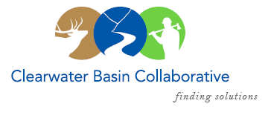

Clearwater Basin Collaborative
Steering Committee
July 14, 2016 - 8:30am PAC/9:30am MTN
Conference Call: (208) 252-6102, no pin required

AGENDA

Discussion Items
- Notes from May 11, 2016
- July 27th Working Group Meeting (Co-Chairs, All)
  - Regional Forester Leanne Marten Visit
  - Director of Idaho Parks & Recreation David Langhorst Visit
  - Call for Agenda items
- Membership / Succession Planning Strategy (Co-Chairs)
  - Update on Outreach
  - Convene Nominating & Operating Protocol Committee
- CBC Visits Region Leadership on Recreation (see attachment, FYI)
- CFLR Project – Clear Creek Litigation (Co-Chairs)
  - Development of Overall Strategy
- Forest Service Changes (Co-Chairs)
  - Dan Hollenkamp, Acting Deputy Forest Supervisor
- Correspondence (Kelli)
  - Response from Chairman Miles, Nez Perce Tribe
  - Ralph Rau Appreciation
  - Chairman Miles, Nez Perce Tribe
  - Chris Wood, Trout Unlimited
  - Land Tawney, Back Country Hunters & Anglers
  - Blake Henning, Rocky Mountain Elk Foundation
- Committee Member Agenda Item Requests (All)
- Calendar of Events (All)

