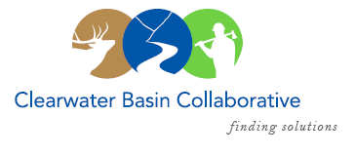

Clearwater Basin Collaborative
Steering Committee
June 14, 2017 - 8:30am PAC/9:30am MTN
Conference Call: (208) 252-6102, no pin required

AGENDA

Discussion Items
- Notes from May 10, 2017 (Co-Chairs)
- National Stewardship Trail Act – Update (Kent Wellner)
- Orogrande Fuels Project (Bill Higgins)
  - Amicus Brief Status
  - Next steps
- June & July Working Group Meeting and Agenda (Co-Chairs, All)
  - Theme and planning
- Wildlife Habitat Restoration Initiative (Alex/Kelli)
  - MOU with Washington State University
- August Recess Planning (Co-Chairs, All)
- Collaboration Cadre (Brad Smith)
- SRS Bill – Senate/House Status (Mike Hanna)
- Selway Middle Fork CFLR (Mike/Tera)
  - President’s Budget Recommendation - $0
  - July 27th Washington Office – Missoula Meeting
- Committee Member Agenda Item Requests (All)
  - Communications: Facebook Page Proposal

