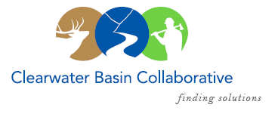

Clearwater Basin Collaborative
Steering Committee
March 8, 2017 - 8:30am PAC/9:30am MTN
Conference Call: (208) 252-6102, no pin required

AGENDA

Discussion Items
- Notes from February 8, 2017 (Co-Chairs)
- Nez Perce-Clearwater General Management Review – March 13-16
  - How can CBC help?
  - Potential multiple interactions/presentations –Higgins, Miller, Rosellini, Doman
- National Stewardship Trail Act (Randy/Alex)
  - Next Steps?
- March Working Group Agenda – Wildlife Habitat Restoration Initiative (All)
  - Facilitation: Olleke Rappe Daniels
  - Pacific Northwest Research Station – Mike Wisdom
  - National Council for Air & Stream Improvement – John & Rachel Cook
  - Forest Plan Revision – Presentation request on wildlife
  - Forest Service – Request Forest and Region participation
- Boise Meetings Report Out
  - Idaho State Meetings (Alex/Joyce/Bill/Tera)
    - Parks & Rec, Lands, Fish & Game, Lt. Governor
  - IFRP Conference (Elayne/Alex)
- CFLR Project – Status Report (Tera/Mike W.)
  - Annual Planning Session - Missoula
  - FY 16 Annual Report / FY 17 Priorities
  - Monitoring Advisory Committee Meeting – March 30
- Wildlife Habitat Restoration Initiative (Alex/Kelli)
  - March 21 Technical Team Meeting - Capture
  - March 22 Technical Team Meeting - Vegetation
- Correspondence & Status Update (Co-Chairs)
  - Trails Act Letter to Probert & Marten
- Committee Member Agenda Item Requests (All)
- Calendar of Events (All)

