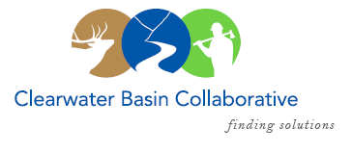

Clearwater Basin Collaborative
Steering Committee
March 9, 2016 - 8:30am PAC/9:30am MTN
Conference Call: (208) 252-6102, no pin required

AGENDA

Discussion Items
- Notes from February 10, 2016
- Boise Report Out (All)
  - Idaho Dept. of Lands
  - Idaho Dept. of Fish & Game
  - Idaho Dept. of Parks & Rec
  - CBC Hospitality Reception
- All Co-Chair Meeting Report Out (Olleke, Co-Chairs)
  - Plan of Work
  - Recommendations for Working Group
  - Memorandum of Understanding
- Agreement & Work Plan Committee Report Out (Elayne/All)
- North Central Idaho RAC Request (Alex)
- Nominating & Operating Protocol Committee
  - Operating Protocols for March Meeting
  - Elections for March Meeting
- Wildlife Habitat Restoration Initiative (Alex/Kelli)
  - Technical Committee Report Out
  - Summer Vegetation Work
- Landscape Forest Health Subcommittee (Tera)
- Committee Member Agenda Item Requests (All)
- Calendar of Events (All)
- Other

