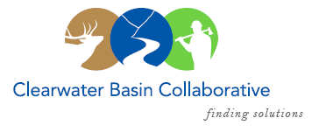

Clearwater Basin Collaborative
Steering Committee
May 11, 2016 - 8:30am PAC/9:30am MTN
Conference Call: (208) 252-6102, no pin required

AGENDA

Discussion Items
- Notes from April 13, 2016
- Membership / Succession Planning Strategy Update (Alex)
  - Trout Unlimited
  - Back Country Hunters & Anglers
  - Nez Perce Tribe
- May 25th Retreat Planning (Olleke, Co-Chairs)
  - Logistics – The Edge and Best Western Hotel
  - Agenda
    - Full Day Meeting on 25th
    - Dinner on 24th and possibly 25th
- Notice to Steering Committee (All)
  - Idaho County Nez Perce Travel Management Objection Notice
  - Idaho County Suction Dredge Mining Objection Notice
- CFLR Project (All)
  - Johnson Bar
  - Clear Creek
- Forest Service Changes
- Wildlife Habitat Restoration Initiative
  - Funding Secured (Alex)
- Committee Member Agenda Item Requests (All)
- Calendar of Events (All)

