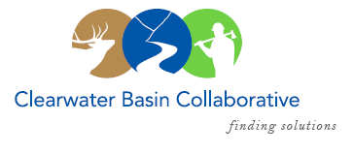

Clearwater Basin Collaborative
Steering Committee
November 9, 2016 - 8:30am PAC/9:30am MTN
Conference Call: (208) 252-6102, no pin required

AGENDA

Discussion Items
- Notes from October 12, 2016 (Co-Chairs)
- CFLR Project (Mike W.)
  - Program of Work (circulate Plan)
  - Clear Creek Status Report
  - Revised/Amended CFLR Proposal & FY 16 Annual Report
- December Working Group Agenda Development (All)
  - Wildlife Habitat Restoration Initiative
  - Forest Plan Revision – Presentation request on wildlife
  - Selway Middle Fork CFLR
  - Regional Office Coordination
- Sustaining CBC’s Momentum – In lieu of November Meeting (All)
  - Subcommittee Meetings
    - Recreation
    - Forest Health
    - WHRI Executive Committee
  - Communications and Diplomacy
    - Rocky Mountain Elk Foundation
    - USFS Regional Office
    - Senator Crapo’s Office - Boise
    - Other
- Washington DC Considerations (Co-Chairs)
- Membership / Succession Planning Strategy – Update (Co-Chairs)
  - Continuing Diplomacy: Nez Perce Tribe (see attached correspondence)
  - Working Group Vacancies
- January All Co-Chair Meeting – Coeur d’Alene (Co-Chairs)
  - Facilitation - Olleke
  - Agenda
- Correspondence (Kelli)
  - Darren Parker, Senator Risch’s Office
  - Kent Wellner, USFS Region 1
  - Kathryn Tacke, Idaho Dept. of Labor
- Partner Changes (Alex)
  - Mike Ward, Interim Moose Creek District Ranger
- Committee Member Agenda Item Requests (All)
- Calendar of Events (All)

