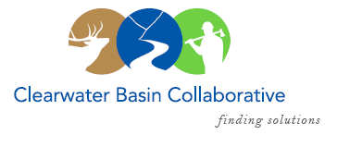

Clearwater Basin Collaborative
Steering Committee
October 11, 2017 - 8:30am PAC/9:30am MTN
Conference Call: (208) 252-6102, no pin required

AGENDA

Discussion Items
- Notes from September 13, 2017 (Co-Chairs)
- Collaboration Cadre (Dale/Kelli)
  - Timeline and What’s Ahead
  - CBC’s Engagement Team
- Selway Middle Fork CFLR (Mike/Tera)
  - Missoula Strategy Session – Nov 9-10
  - Ecosystem Services Survey – Ben Fitch-Fleischman, ERG
  - Washington Office visit reschedule to October 27
- October Working Group Meeting and Agenda (Co-Chairs, Elayne)
  - Dan Isaak, RMRS – effects of wildlife to water quality and fish
  - Bob Lippincott, FMO Nez Perce-Clearwater National Forest
  - Elections for Steering Committee (Kelli)
  - Request for Agenda Items
- Wildlife Habitat Restoration Initiative (Alex, Kelli)
  - Helicopter RFQ Results
  - MOA with Washington State University
  - Contract with Cooks
- Idaho GEM Trail (Alex)
  - Fence Moving Work Party
  - South Zone Progress
- Committee Member Agenda Item Requests (All)

