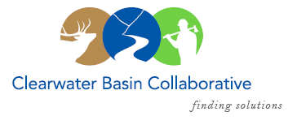

Clearwater Basin Collaborative
Steering Committee
October 12, 2016 - 8:30am PAC/9:30am MTN
Conference Call: (208) 252-6102, no pin required

AGENDA

Discussion Items
- Notes from September 13, 2016
- Correspondence
  - Wildland Fire Support Letter
- October Working Group Agenda Development
  - Forest Plan Revision (see attachment) - Dale
  - Darren Parker, US Senator James Risch’s Office - Dale
  - Kathryn Tacke, Idaho Dept. of Labor - Kelli
  - Congressional Update / Activities
    - American Forest Resource Council - Mitch
    - Chief’s Meeting in Missoula – Mitch/Mike/Scott
    - Governor’s Meeting – Oct 20-21st – Dale
- Liaisons and Partners at the Working Group Table
  - Idaho Dept. of Lands
  - Idaho Dept. of Parks & Recreation
  - US Army Corps of Engineers
  - Bureau of Land Management
- Membership / Succession Planning – Update (Co-Chairs)
  - Vacancies: Working Group
    - Trout Unlimited
    - Back Country Hunters & Anglers
- November Working Group Meeting – Date Adjustment?
- Wildlife Habitat Restoration Initiative - Kelli
  - Vegetation Technicians Complete
  - Fall Capture Activities
- Committee Member Agenda Item Requests (All)
- Calendar of Events (All)

