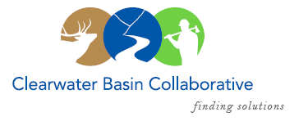

Clearwater Basin Collaborative
Steering Committee
September 13, 2017 - 8:30am PAC/9:30am MTN
Conference Call: (208) 252-6102, no pin required

AGENDA

Discussion Items
- Notes from August 12, 2017 (Co-Chairs)
- Collaboration Cadre (Dale/Mitch Silvers)
  - Message to Membership
  - Timeline and What’s Ahead
  - CBC’s Engagement Team
- Landscape Forest Health (Bill/Mike/Kelli)
  - Dixie Comstock
  - East Saddle
  - Forest Service Engagement (Mike)
- Idaho GEM Trail (Randy/Kelli)
  - Pankey Easement
  - South Zone Progress
- Selway Middle Fork CFLR (Mike/Tera)
  - Lowell WUI
  - Washington Office visit reschedule to October 27
  - Missoula Strategy Session – reschedule due to fire
- September Working Group Meeting and Agenda (Co-Chairs, Elayne)
  - Forest Plan Revision
  - Request for Agenda Items
- Correspondence:
  - Probert, Idaho Roadless Rule letter
- Committee Member Agenda Item Requests (All)

